SDP

The SDP in Charging System contains the database with subscriber and account information. It performs the charging analysis of prepaid calls and can also perform charging based on incoming CDRs. The SDP also sends notifications through USSD or SMS.

The SDP graphical user interface (GUI) consists of two main applications; SDP Management Application (SMA) and Tariff Management Application (TMA).

SMA is used for administration of the SDP node. The most relevant for us are prepaid price plans definition, free numbers list definitions and the database with subscriber and account information.

TMA is used for creation and administration of the selection structures on the SDP node. We just are going to perform tariff structures.

Next, we explained in detail these two applications.

SMA

This is the first screen you display when the GUI is started:

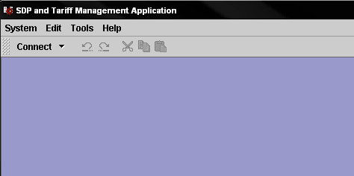

Use the System menu to connect to one of the available SDPs (System → Connect → Connect to…).

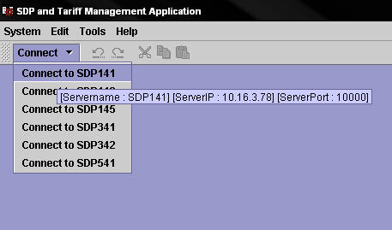
Next a login must be performed in the Login window that appears. Type user name and password with “colmova” and “sanchinarro55” as you can see in the image below:

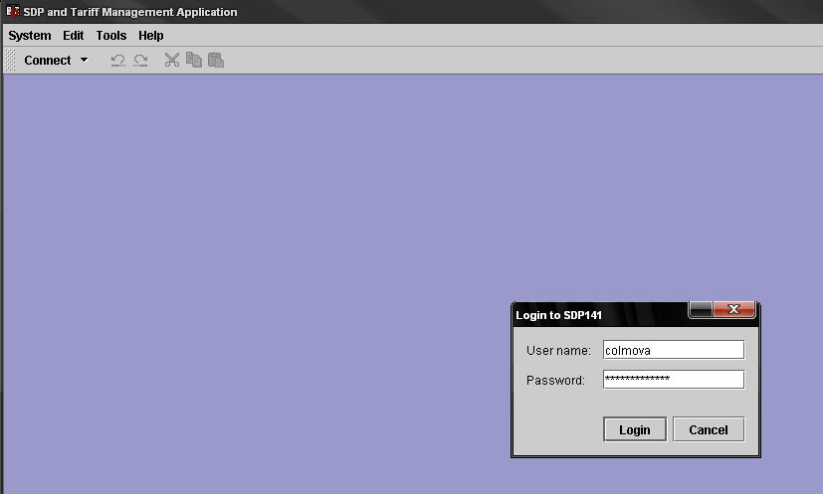

Then press Login button to log in.

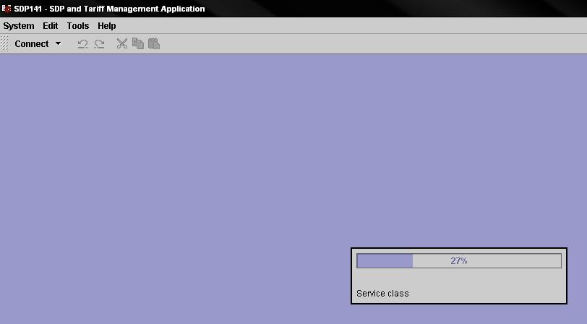

When a login has been performed, the different functions in the GUI can be accessed from the menu bar.
The menus contain all the functions available, such as Tariff and Service Class administration, Statistics, and so on. The functions are gathered into four principal groups called Call Settings, SDP admin, Events and Sys admin. We only use Call Settings menu, the others are task of Vodafone.

Call Settings Menu

The Call Settings menu holds functions for tariff and service class administration.

Number Lists

The Number Lists window, in the SDP Management Application is used for specifying the number lists that are common for all subscribers, independent of service class.

Number lists can be used to bar the subscribers from certain numbers or number series, or to allow certain calls to be made free of charge during different service scenarios.

To open the Number Lists window, select Number lists in the Call Settings menu.

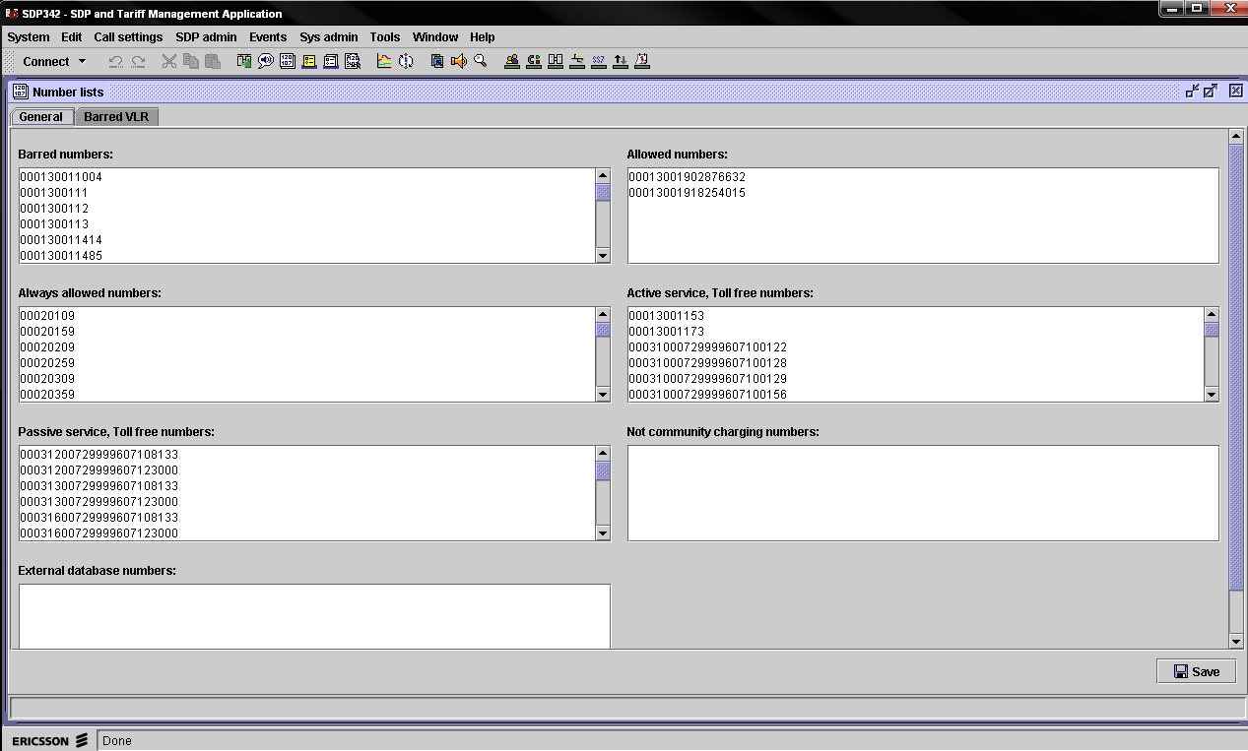

In this window, number lists can be created that are valid for all service classess. The General tab contains different lists of subscriber numbers, while Barred VLR contains VLR numbers that are barred for USSD call-back calls, but this last is task of Vodafone too.

To add a number or a number series to one of the lists containing subscriber numbers, you have to make a new NCR to O&M Alicante team do.

If only part of a subscriber number is started in a number list, for example, 19, all numbers beginning with 19 are included in the list. If an interval is specified, for example, 34-37, this means that all numbers beginning with 34, 35, 36 and 37 are included.

Note: The two numbers defining an interval must have the same number of digits. For example, an interval cannot be specified as 34-372, whereas 340-372 is a valid interval.

Field | Description
Barred numbers | Numbers or number series that cannot be used by the subscriber.
Allowed numbers | Numbers or number series that can be used during all service scenarios (active, passive, and no-service) to make toll-free calls.
Active service, Toll free numbers | Toll-free numbers or number series that can be used by subscribers who have access to active service.
Passive service, Toll free numbers | Toll-free numbers or number series that can be used by subscribers who have access to passive service.

In all cases, it is possible to define 1000 different numbers or number series.

The different number lists that have been defined are checked in the order illustrated in figure below. A particular list defined for a service class and the corresponding common list are checked together as one list. Roaming lists defined for the service class are included in this check.

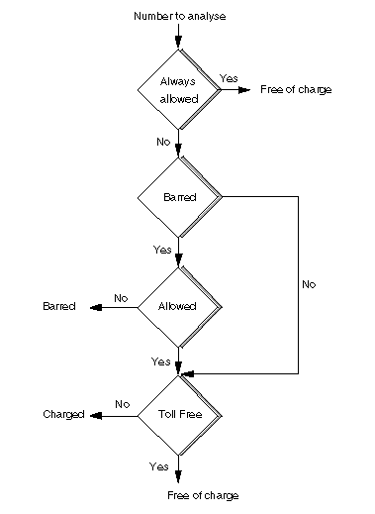

Service Class
The subscriber can choose between a number of different service classes that offer pre-customized services to a group of subscribers. The Charging System operators have their own sets of service classes to offer on the market.

The Service Class window in the SDP Management Application is used to create, edit and delete service classes.

To open the Service Class window, select Service class in the Call settings menu.

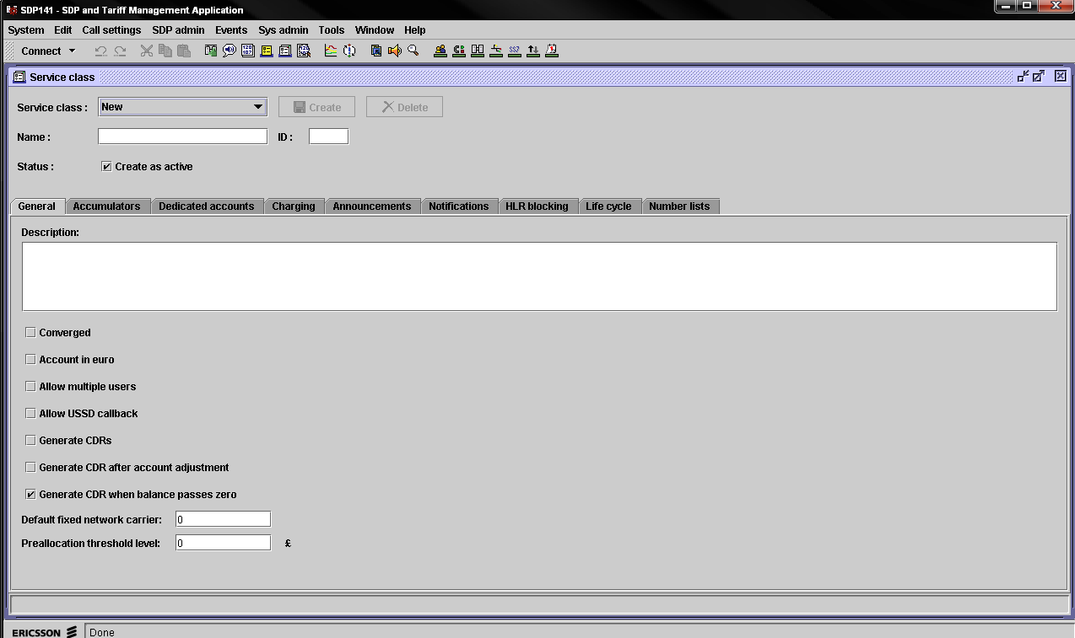

This window enables the user to change service class data and to create and delete service classes (Prepaid Catalog Team only have read permissions; all tasks that requires write permissions, are made by O&M Alicante, through a NCR that will make us).

The header contains a checkbox for changing the activation status of a service class. When a new service class is created, it can be created as active or inactive.

Now we are going to describe principal elements that we will use in the Service Class window header:

- Service class: Select an existing service class from this drop-down menu to display an d edit its data.
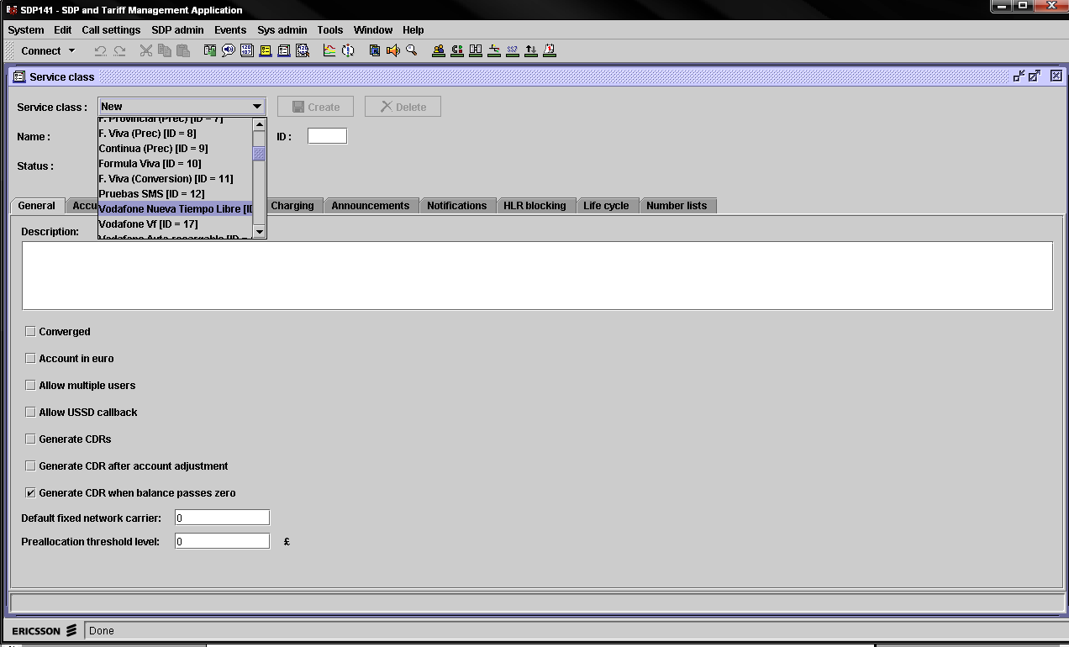

- Name: Unique name of the service class. The name must be entered by the user when creating a new service class.

- ID: Unique ID of the service class. The ID must be entered at creation and is used to identify the service class in the database.

- Status: Checkbox for activating or inactivating the service class. A new service class can be created as active or inactive.

An inactive service class cannot have any subscribers connected to it.
When a service class has been activated, there are many service class settings which cannot be changed anymore. These settings are the following:

Tab | Setting in Tab
General | Account in euro  Allow USSD callback
Accumulators | None
Dedicated accounts | None
Charging | PrePaid empty limit  PostPaid empty limit  Negative balance grace period
Announcements | None
Notifications | None
HLR blocking | All settings with the following exception:  In the GPRS control area, it is still possible to change the setting Disconnect session when barred.
Life cycle | Allow pre-activation of accounts
Number lists | None

Note: The name and ID for an existing service class cannot be changed.

The settings made for a service class is divided into the following areas:

- General: Deals with general service class settings such as the currency of accounts and if multiple users are allowed. The only setting we inform in NCR is Description field; it is for entering general information about the service class. It’s optional.

- Accumulators (AT THE MOMENT, ONLY TASK OF VODAFONE): Deals with settings such as the activation of accumulators and the rules for creation and deletion of accumulators.

- Announcements (AT THE MOMENT, ONLY TASK OF VODAFONE): Deals with settings such as the default language for announcements and whether or not to play certain announcements.

- Dedicated accounts (AT THE MOMENT, ONLY TASK OF VODAFONE): make it possible to allocate money for a dedicated use (for example, Voice, SMS, GPRS). Different dedicated accounts structures can be created.

- Notifications (AT THE MOMENT, ONLY TASK OF VODAFONE): Deals with the settings for balance and life cycle notification to external systems.

- HLR Blocking (AT THE MOMENT, ONLY TASK OF VODAFONE): Deals with settings that define the services to be available in the HLR and the rules and thresholds used for barring/unbarring of the services.

- Life Cycle (AT THE MOMENT, ONLY TASK OF VODAFONE): Deals with the criteria for active and passive service and the settings for preactivated accounts and service fee deduction.

- Number Lists (AT THE MOMENT, ONLY TASK OF VODAFONE): Deals with numbers and number series that are always allowed without charge, toll-free depending on the service scenario, or barred.

View Account

The View Account window in the SDP Management Application enables the user to view account data for subscribers in the system. The window is only for viewing purposes.

Prepaid subscriptions are handled in the SDP and in the network operator’s system for subscriber administration.

To open the View Account window, select View account in the Call settings menu.

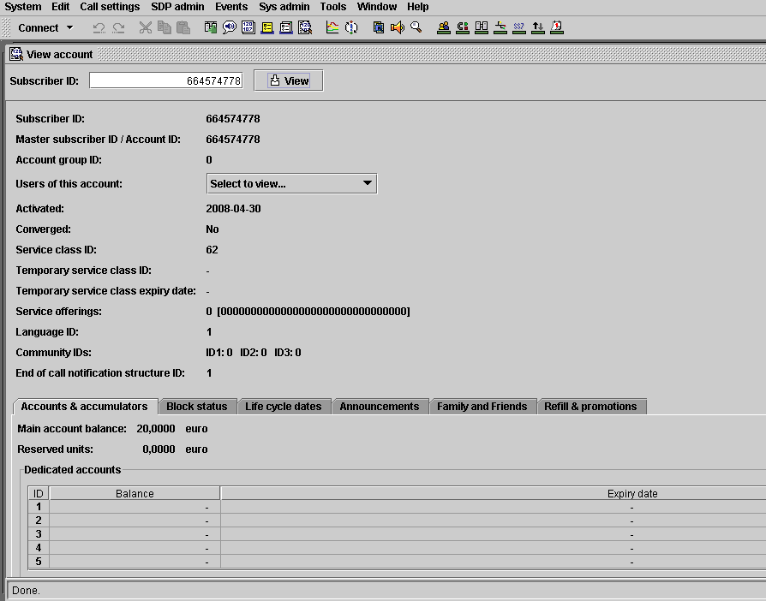

To display account information, enter an existing subscriber number in the Subscriber ID text field and press the View button.

General data (for example, activation date and service class ID) are displayed at the top of the window.

The following information about the viewed account is displayed at the top of the window:

Field | Description
Subscriber ID | The subscriber number entered by the user.
Master subscriber ID / Account ID | The master subscriber number for this account.
Account group ID | The account group to which the subscriber belongs.
Users of this account | Drop-down menu containing all sub-accounts connected to the master account. Make a selection in the menu to view the information for the selected user.
Activated | The date when de account was activated.
Converged | Displays whether the subscriber belongs to a converged service class or not (Yes/No).
Service class ID | The service class for the account. Each service class has a unique ID. The ID is entered at creation and is used to identify the service class in the database.
Temporary service class ID | The service class to which the account is temporarily connected.  By using a value voucher, a subscriber can change to another service class for a fixed period to take advantage of, for example, lower tariffs.
Temporary service class expiry date | The date when the account will be switched back to its original service class.
Service offerings | The value of the account’s service offering parameter.
Language ID | The language ID for the account.
Community IDs | The community IDs defined for the account.
End of call notification structure ID | The ID of the USSD text message structure to be used for the subscriber. The SDP can optionally be configured to send the text messages through SMS.

The following information about the viewed account is displayed in the Accounts & accumulators tab:

Field | Description
Main account balance | The balance of the account
Reserved units | The number of monetary units reserved for any ongoing calls.
Dedicated accounts | Display Balance and Expiry date for dedicated accounts used by the account. The expiry date may be unspecified, in which case a dash is shown. If expiry date is unlimited, the field is empty.  Dedicated account ID range is 1-5.
Accumulators | Displays Counter value, Last reset date and Next reset date for accumulators used by the account.  Accumulator ID range is 1-5.

The following information about the viewed account is displayed in the Block status tab:

Field | Description
Temporary block | Displays if the account is temporary blocked or not (Yes/No).  With Temporary blocking of a subscriber, it is possible to bar/disconnect certain traffic, or prevent changes of account data during, for example, migration.
Marked for disconnect | Displays if this account is marked for disconnection or not in the SDP database (Yes/No).  The action of disconnecting the account is taken by the external administration system.
Negative balance barred | Displays if this account is negative balance barred or not (Yes/No).  The negative balance grace period is defined in the service class an specifies for how long an account is allowed to be below zero. If the grace period expires, the subscriber is denied service and negative balance barring is performed. The subscriber is not temporary blocked since the desired action form the subscriber is to make a refill to clear the debt.
Blocking status table | For each Type of service, the table displays the Actual state and the Wanted state.  The Wanted state is the appropriate blocking state as determined by, for example, the current account balance and the CDR thresholds for offline services. The Actual state can be different since the SDP may be delayed by a communication failure when trying to block / deblock the subscriber in the HLR. Possible blocking status values are Allowed and Blocked.  The following types of service are listed in the table:  - Originating voice  - Terminating voice  - Originating SMS  - Terminating SMS  - GPRS

The following information about the viewed account is displayed in the Life cycle dates tab:

Field | Description
Service fee expiry date | Date when the service fee period for the account will expire. If the service fee period expires, the account state will change according to the service settings. If there still has not been a refill after a grace period, the account will be marked for disconnection.
Supervision expiry date | Date when the supervision period for the account will expire. If the supervision period expires, the account state will change according to the service class settings. If there still has not been a refill after a grace period, any credit on the master account and all available dedicated accounts will be cleared.
Account disconnect date | Date when the account will be marked for disconnection in the SDP database if a refill is not performed. The action to delete the account is taken by the external Admin System.
Credit clearance date | Date when the account will be cleared if a refill is not performed.
Last service fee deduction | Date when the periodic service fee was last deducted.
Negative balance barring start date | Date when the account will be barred due to negative balance. If the account balance is positive, No is displayed.
Negative balance barred | Date when the account was negative balance barred. If the account is not barred, No is displayed.

